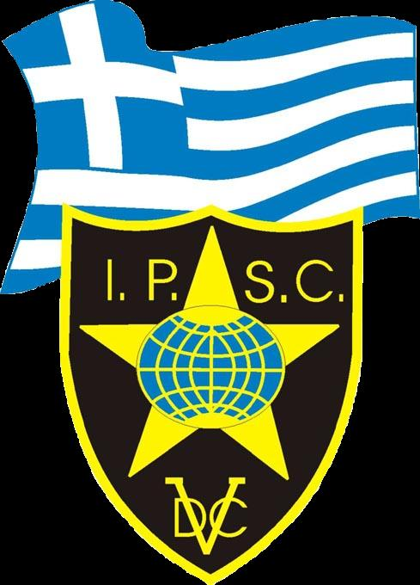 Hellenic Shotgun Nationals 2010 Stage 13
RULES: Practical Shooting Handbook, Latest Edition Course Imprint: Stavros Stavridis
START POSITION: Standing relaxed facing down range, on start, gun loaded ready condition.
Course of Fire : Medium Stage  STAGE PROCEDURE  On start signal shoot all targets as they become visible, remaining inside the designated area while shooting. | SCORING: Comstock.  TARGETS: , 12 Metal Plates.  POSSIBLE POINTS: 60.  MINIMUM ROUNDS: 12 rounds Birdshot.  SCORED HITS: 2 Best per IPSC, steel down = 1A  START-STOP: Audible - Last shot  PENALTIES: As per current edition IPSC rules.  STAGE PERCENTAGE: %
SETUP NOTES:  DISTANCE: |  | RO NOTES:

